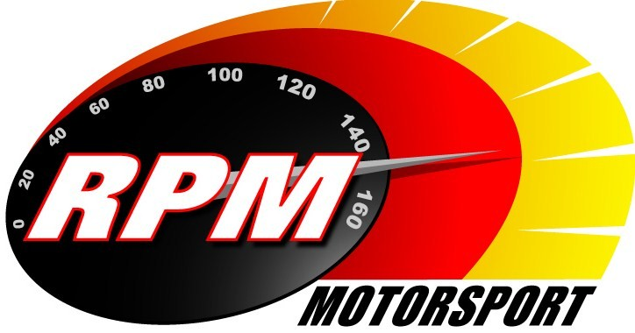
TV BILLINGS OCTOBER – NOVEMBER 2011
Ireland’s Leading Motorsports Programme

Setanta Sports, Motors TV – From Monday 3RD. October – Adelaide Masters Motorcycles – Supersports 600s
Highlights from the third Mondello Adelaide Masters motorcycle race meeting featuring the Supersports 600s. Karen Feeney, Jim Hannigan, and Leo Nulty report.

Setanta Sports, Motors TV – From Monday 10th. October – Fisher Engineering Lakeland Stages Rally.
Rally action from the forests of Fermanagh in the Hankook Norther Ireland Rally Championship series. Andrew Bushe, Gary Gillespie, and Alan Tyndall report.

UTV - Thursday 13th. October - 11.10pm.* - Cork 20 International Rally.
Highlights from the final round of the Irish Tarmac Rally Championship, with the new Irish National Rally Champion Tim McNulty going for the two big titles in 2011. Andrew Bushe, Gary Gillespie, and Alan Tyndall report.

Setanta Sports, Motors TV – From Monday 24th. October – Cork 20 International Rally.
Highlights from the final round of the Irish Tarmac Rally Championship, with the new Irish National Rally Champion Tim McNulty going for the two big titles in 2011. Andrew Bushe, Gary Gillespie, and Alan Tyndall report.

UTV - Thursday 27th. October - 11.10pm.* - Adelaide Masters Superbike Races – Superbikes.
Highlights from the fourth Mondello Adelaide Masters motorcycle race meeting featuring the Superbikes. Karen Feeney, Jim Hannigan, and Leo Nulty report.

UTV - Thursday 3rd. November - 11.10pm.* - Adelaide Masters Superbike Races – Supersports 600s.
Highlights from the fourth Mondello Adelaide Masters motorcycle race meeting featuring the Supersports 600s. Karen Feeney, Jim Hannigan, and Leo Nulty report.

Setanta Sports, Motors TV – From Monday 7th. November – Adelaide Masters Superbike Races – Superbikes.
Highlights from the fourth Mondello Adelaide Masters motorcycle race meeting featuring the Superbikes. Karen Feeney, Jim Hannigan, and Leo Nulty report.

Setanta Sports, Motors TV – From Monday 14th. November – Adelaide Masters Superbike Races – Supersports 600s.
Highlights from the fourth Mondello Adelaide Masters motorcycle race meeting featuring the Supersports 600s. Karen Feeney, Jim Hannigan, and Leo Nulty report.

*Check with local papers for late schedule changes.

For further information contact:-
Paul McAuley Tyndall Productions 58 Edentrillick Road Hillsborough BT26 6PG. Tel 02892 689444. E-mail paul@rpm-motorsport.com

