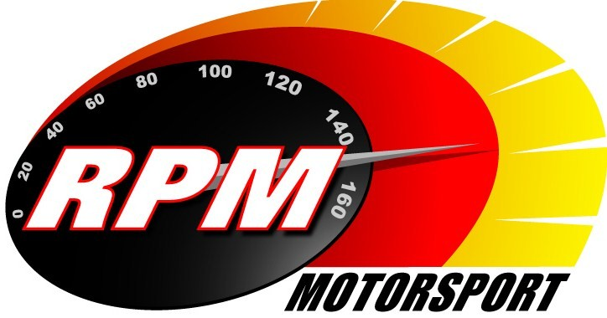
TV BILLINGS February 2012
Ireland’s Leading Motorsports Programme

UTV - Thursday 16th. February - 11.00pm.* - Safety Direct Galway International Rally I
Eugene Donnelly (WRC Mini), Gareth MacHale (WRC Focus), and the 2011 champion Tim McNulty (WRC Subaru), head a spectacular 150 car entry on the opening round of the Irish Tarmac Rally Championship. RPM brings you highlights from the opening stages. Andrew Bushe, Gary Gillespie, and Alan Tyndall report.

TG4 – From Tuesday 21st. February. – Safety Direct Galway International Rally I
Highlights from the opening stages of the first round of the Irish Tarmac Rally Championship. Andrew Bushe, Gary Gillespie, and Alan Tyndall report.

UTV - Thursday 23rd. February - 11.00pm.* - Safety Direct Galway International Rally II
Part two of RPM’s coverage of the opening round of the 2012 Irish Tarmac International Rally Championship. Andrew Bushe, Gary Gillespie, and Alan Tyndall report.

TG4 – From Tuesday 28th. February. – Safety Direct Galway International Rally II
Part two of RPM’s coverage of the opening stages of the first round of the Irish Tarmac Rally Championship. Andrew Bushe, Gary Gillespie, and Alan Tyndall report.

Setanta Sports, Motors TV – From Monday 29th. February – Safety Direct Galway International Rally I
Highlights from the opening stages of the first round of the Irish Tarmac Rally Championship. Andrew Bushe, Gary Gillespie, and Alan Tyndall report.

Setanta Sports, Motors TV – From Monday 5th. March – Safety Direct Galway International Rally II
Part two of RPM’s coverage of the opening round of the Irish Tarmac Rally Championship. Andrew Bushe, Gary Gillespie, and Alan Tyndall report.

*Check with local papers for late schedule changes.

For further information contact:-
Paul McAuley Tyndall Productions 58 Edentrillick Road Hillsborough BT26 6PG. Tel 02892 689444. E-mail paul@rpm-motorsport.com

