ARTICLE 3 Cont.

Please do not phone club officials, as faxes will be answered promptly Entry Fee €435 Junior & Historic €250.00 (payment in Euro only) DO NOT SEND CASH WITH ENTRY No Cheques will be cashed until the closing date for entries. Above to start event at SS4

This includes standard rate I.R.D.S., Personal Accident premium per Crew.

All drivers must be the holders of (and must produce) a valid letter of acceptance from one of the following I.R.D.S. / B.R.D.S. insurance schemes.

ARTICLE 4
(a) Pace notes will be allowed on this event and competitors will be allowed to make pace notes on Saturday, 11th May only, between the hours of 9^{am} and 4:30^{pm} Reconnaissance is limited to a maximum of three passes per stage or any part thereof. in accordance with the regulations as printed in the current M.I. Yearbook.

(b) Competitors making pace notes are obliged to register at Rally Headquarters, The Mount Wolseley Hotel, between the hours of 8.30^{am} and 12.00 Noon. on Saturday 11th May.

(c) Pace Notes may be available for sale from third parties. The club has no involvement with their preparation or sale and accepts no responsibility for their accuracy or otherwise.

TIMETABLE
2nd April Entries open.
30th April Entries close.
7th May Final instructions posted on www.mkiichallenge.com
11th May 8:30 – 12 Noon. Register for recce.

SCRUTINY
3.30^{pm} - 7-30^{pm} Saturday 11th May Scrutineering for all crews. Sunday Scrutineering applications may be submitted to COC.

LOUGH FEILIM INDUSTRIAL ESTATE, CARLOW ROAD, TULLOW, CO CARLOW

07:30^{am} Drivers Safety Briefing will be held in Park Ferme, weather permitting. Any change will be posted on the Official Notice Board in Rally Office. A Competitors Safety Briefing is compulsory for all events. The briefing must highlight safety requirements particularly the procedure dealing with SOS & OK boards. A two minute penalty may be applied if at least one member of each crew has not attended this briefing.

08:00^{am} First car away,
16:20^{pm} First car finish,

Provisional results not before 17:30
Prize giving 19:00 (approx.)

The Promoters reserve the right to postpone cancel or abandon the event or any part thereof The Promoters reserve the right to refuse an entry without having to assign a reason.

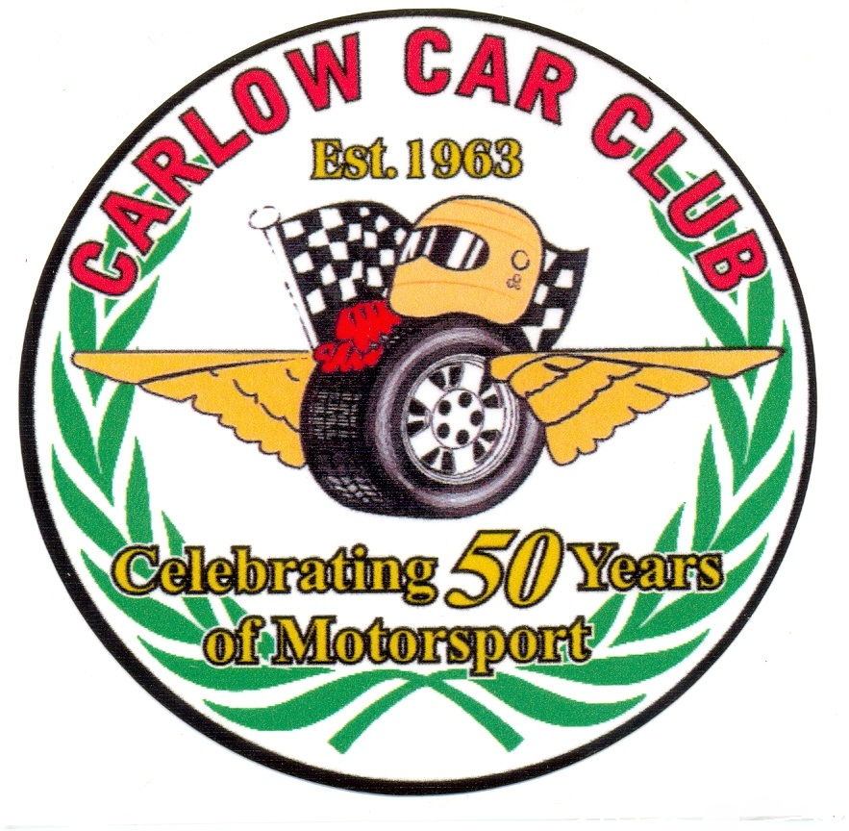
Regulations for CARLOW STAGES RALLY 2013
Sponsored by Mount Wolseley Hotel, Spa & Golf Resort
& FORD ESCORT MARK II CHALLENGE
12th May 2013

A Round of the South East Stages Rally Championship,
Sponsored by Triton Showers and round 5 of the Carlow Car Club members Championship.
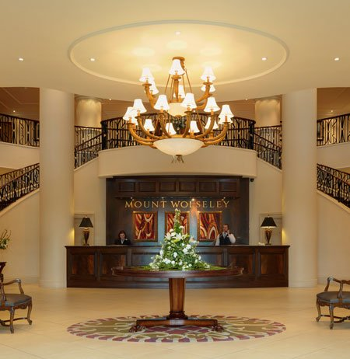
www.mountwolseley.ie 059 91 80100

Running Motorsport events from 1963 to 2013

Organised and promoted by

Carlow Carsports Club Ltd
.
OFFICIALS

Motorsport Ireland Stewards Alan Verso/ Marty Sherlock.
Motorsport Ireland Safety Officer Robert Lyttle.
Motorsport Ireland Scrutineering John Mc Cabe & Team
Club Steward John Naylor.
Clerk Of The Course Terence O’Shaughnessy.
Deputy C.O.C. John Meaney.
Assistant C.O.C’s Aidan Kelly, Robert Corrigan.
Secretary of the event Charlotte Egan.
Assistant secretary Fiona Cullen Driver
Club Safety Alan Corrigan.
Press Officer Seamus Doyle.
Chief Timekeeper TBA
Results Angus Sealy.
Chief Marshal Martin Comerford.
Chief Medical Officer Dr Mary Hooper.
Comp Liaison Officer Johnny Baird.
Chief Rescue Athlone Rally Rescue.
Radio Controller Mary Fitzgerald.
Road close Martin Delaney.
Eslo Officer Padraig Dooley.
Car Accountability James Lakes.

CLASSES
1 Group N up to 1400 cc, 5 Group A up to 1400 cc,
2 Group N 1401 cc to 1600 cc, 6 Group A 1401 cc to 1600 cc,
3 Group N 1601 cc to 2000 cc, 7 Group A 1601 cc to 2000 cc,
4 Group N Over 2000 cc, 8 Group A Over 2000 cc,
Class 9. Modified cars up to 1450cc - 2 wheel drive.
Class 10. Modified cars 1451cc to 1650cc not more than 2 valves per cylinder, 2 wheel drive.
Class 11. Modified cars 1451cc to 1650cc more than 2 valves per cylinder, 2 wheel drive.
Class 12. Modified cars 1651cc to 2100cc not more than 2 valves per cylinder, 2 wheel drive.
Class 13. Modified cars 1651cc to 2100cc more than 2 valves per cylinder, 2 wheel drive.
Class 14. Modified cars 2101cc to 3500cc, 2 wheel drive.
Class 15. Four-wheel drive cars whose homologation has expired. See notes 3 & 5
Class 16 Junior Class Up to 1450cc as per MI Regulations.
Class 17 Junior Class 1451cc to 1650cc as per MI Regulations.
Class 18 Historic Cars in possession of HTP or HRVIF as per App 29 of MI Yearbook .
Class 20 For Four Wheel Drive (4WD) Cars – See note below

Class 20 for Four Wheel Drive (4WD) Cars
4WD (forced induction or normally aspirated) cars modified to an extent not permitted for homologated versions; non homologated 4WD production cars; and cars authorised for use at the discretion of Motorsport Ireland under Appendix 29, Category 2.
In addition to “guidelines for Modified Cars (Category 1)” (available from www.motorsportireland.com), the following applies:
1. Forced induction cars/engines which are or have been homologated must run to their last allowed restrictor size. Proof of compliance lies with the competitor (unless homologation papers are produced at scrutiny showing a larger restrictor, a 32mm restrictor is the maximum permitted.)
(Engine takes precedence when determining the restrictor size).
2. Cars must run to the following vehicle minimum weight limits.
Forced induction with a 32mm restrictor / normally aspirated up to 2100 cc: 1230 kg
Forced induction with a 33mm restrictor: 1280 kg
Forced induction with a 34mm restrictor / normally aspirated 2101-3500 cc: 1330 kg
3. Cars in class 20 must maintain all original suspension mounting points and bulkheads - NO local modifications allowed (unless homologated by FIA for the vehicle).
3.1 For cars converted to 4WD (category 2) logbook regulations apply.
4. Other modifications must comply with MI guidelines as laid out in Appendix 29.

Escort Mark II Challenge awards (all eligible Mark II’s) (Entries limited)
21 Ford Escort Mark II Up to 1450cc
22 Ford Escort Mark II 1451cc to 1650cc, 2-wheel drive normally aspirated and with not more than 2 valves per cylinder.
23 Ford Escort Mark II 1451cc to 1650cc, 2-wheel drive, normally aspirated and having more than 2 valves per cylinder.
24 Ford Escort Mark II 1651cc to 2100cc, 2-wheel drive, normally aspirated and with not more than 2 valves per cylinder.
25 Ford Escort Mark II 1651cc to 2100cc, 2-wheel drive, normally aspirated and having more than 2 valves per cylinder.
26 Ford Escort Mark II 2101cc to 2500cc, 2-wheel drive normally aspirated.

An advertising strip must be carried on Windscreen, Bonnet, or front spoiler as supplied by the club.
Entries: Escort MkII Challenge cars priority entry are limited at the discretion of the directors of Carlow Car Club. To qualify for the MkII Challenge the car must have the Mc Pherson type struts (front) & Beam axle (rear).
OVERALL AWARDS CLASS AWARDS
1st Overall 2 Trophies 1st In Class 2 Trophies
2nd Overall 2 Trophies 2nd In Class 2 Trophies
3 rd Overall 2 Trophies 3rd In Class 2 Trophies
Special Awards:
Mark II Challenge awards these are deemed to be manufactures additional awards
Best Club Member (driver) 2 Trophies.
Best NI Crew 2 Trophies.
Kelly Award Highest placed club member.
Ladies award 2 Trophies.
Best Overseas Crew 2 Trophies.
If 5 or more entries are not received in each class the organisers reserve the right to amalgamate Classes or reduce awards accordingly. Competitors may qualify for only one award (except Kelly award).
ORGANISATION
(1) Carlow Stages Rally 2013 is promoted and organised by The Carlow Carsports Club Ltd. hereinafter called the Promoters.
(2) A qualifying round of the South East stages rally championship sponsored by Triton Showers. and round 5 of the Carlow Car Club members Championship
(3) The Rally will take place over a route of approximately 150 Km’s.
(4) These regulations have been submitted to and approved by Motorsport Ireland and the necessary permit for the holding of the competition has been granted. PERMIT NUMBER 13 / 069
ARTICLE 1:
The competition will be held under the International sporting Code of the F.I.A., the General Competition Rules of Motorsport Ireland and these Supplementary Regulations, including appendix 25 & 29 of the Motorsport Ireland Yearbook. All competitors who forward completed entry forms agree to be bound by the rules.
ARTICLE 2:
(a) The Supplementary regulations for the rally are as stated by the Motorsport Ireland Regulations and definitions Motorsport Ireland Yearbook.
(b) Final instructions form an integral part of the supplementary regulations.
ARTICLE 3:
(a) Entries open on publication of the regulations 2nd April.
(b) Entries may be made on line at www.mkiichallenge.com preferred method or paper entry form available on request from www.carlowcarclub.ie
This is an on line process to EVO On-Line Entry. On completion you will be presented with a completed entry form and indemnity you must print, sign and sent to Rally entry secretary Ms. Charlotte Egan, Carlow Car Club, Gilbertsown, Rathoe, Co. Carlow. Along with your entry fee by regular post, when payment is received you will be notified by e-mail or text of your acceptance. Queries to be e mailed to charlotteegan710@hotmail.com
(c) To ensure a safe and successful running of the event we will request you to submit us with the name of 1 person and their contact phone number as a marshal for the event. Our chief marshal will make direct contact with your nominated marshal. We appreciate your co-operation in this matter.

