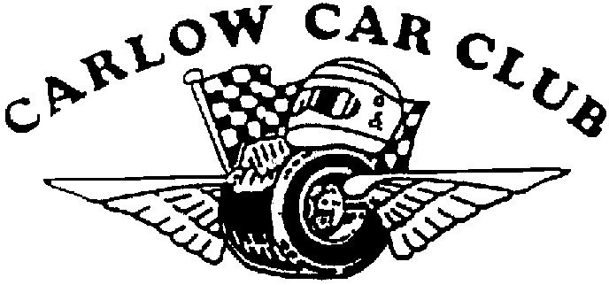
Carlow Stages Rally 2013 Sponsored by Mount Wolseley Hotel, Spa & Golf Resort.
Ford Escort Mark II Challenge Sunday 12th May 2013

FINAL INSTRUCTIONSBULLETIN NO: 1 Issued 07/05

- Crews wishing to reconnoitre the stages may do so (as per the regulations) on Saturday 11th May ONLY between 9.00am and 4.30^{pm} All crews must sign on at Rally Headquarters between 8.30^{am} and 12.00 Noon

2) To minimise congestion during reccee entries with even numbers please start reconnaissance on stages 1 and odd numbers on stages 2.

3) Mechanical Scrutineering 3-30^{pm} - 7-30^{pm}. Saturday 11th May for all crews in Tullow Business park, Rathoe Road Tullow Co Carlow (Sunday scrutiny by appointment ONLY)

4) Reece speed limits - maximum speed allowed on the stages for recce is 60 km/h from start to finish. Please RESPECT THE RESIDENTS AS THEY HAVE BEEN KIND ENOUGH TO COOPERATE WITH THE CLUB FOR THE RUNNING OF THE EVENT.

5) Pace Notes may be available for sale from Brian Patterson, Killian Duffy, Bob Kelly. The club has no involvement with their preparation or sale and accepts no responsibility for their accuracy or otherwise.

6) Trailer park sign posted from Pre event Scrutineering area.

7) Please complete paper Scrutiny (in Rally HQ) as soon as possible when mechanical Scrutiny is completed.

8) Change of Officials
Stewards : Alan Verso and Pat Lordan
Chief Marshal: Michael Comerford
Chief Timekeeper: Karen O’Sullivan

9) Drivers safety briefing on Sunday 7:30^{am} sharp in Tullow Business park, Rathoe Road Tullow (as pre event scrutineering) at least one member from each crew and both junior crew members must attend.

10) Sunday 12th May at 8.30^{am} First car leaves T.C 1. @ Tullow Business park

11) Queries arising during the event should be written on the OFFICIAL QUERY FORM and handed in with time cards.

12) The entry list is available from www.carlowcarclub.ie. Requests for re-seeding must be lodged with the Secretary of the meeting by 1.00^{pm} on Saturday afternoon.

13) All competing cars must use a large non porous mat when in the service area Penalty for not using this mat 2 minutes. Any Competitor or Service crew found speeding or driving dangerously in the service area will be penalised 1 Minute for each occurrence.

14) All accidents on road sections must be reported to C.O.C. for the purposes of Road Traffic Insurances

15) Anyone from the list of accepted entries who fails to inform the secretary of the meeting that they will be unable to compete in the event before 7.00pm on Friday 10th Will be charged an administration fee of €100.

16) Pace note Judges of Fact all event officials and the following:

George Nolan,
Henry Corrigan,
Kieran Reid,
James Lakes,
Brendan Harpur,
Mick Comerford,
Ken Blanch,
Joe Shirley,
Liam Clarke,
Brid Harpur,
Tom Meaney,
Martin Comerford,
Michael Doyle,
Niall Keogh,
Fintan O’Neill

See notice board

17) Competing cars will be permitted to carry advertising as per MI Regulations. No additions are permitted after passing Scrutiny.

18) Juniors and Historic to start at SS4 following main field from Service 1

19) Further instructions may be posted on the official Notice Board.

_______________________ 07/May/2013
Terence O’Shaughnessy
Clerk of the Course

