The event is organised by Carlow Car Club and will be held under the general competition Rules of MI (incorporating the provisions of the International Sporting Code of the F.I.A.) and in accordance with Appendix 80 and 81 of the current Motorsport Ireland Yearbook, copies of which are available on www.motorsportireland.com, and these supplementary regulations. All competitors who forward entry
forms agree to be bound by these rules. Both hills count as round of the Naylor Engineering Hillclimb & Sprint Championship 2013

MOTORSPORTS IRELAND PERMIT NO:13/

LIST OF OFFICIALS
Motorsport Ireland Steward Dave Fitzgerald
Motorsport Ireland Safety Officer Tommy Murphy
Clerk of the Course Ken Treacy
Deputy COC John Meaney
Club Steward Robert Corrigan
Club Safety Officer Martin Delaney
Chief Scrutinieer Pat Tarrant
Chief Marshal Mick Comerford
Event Secretary Charlotte Egan
Assistant Event Secretary TBA
Bike Marshal George Nolan
Paddock Marshal Martin Comerford
Timing & Results Alan Corrigan & Team
Chief Medical Officer Dr. Azhar
Ambulance Order of Malta
Rescue Sat Leinster Rescue
Rescue Sun Leinster Rescue

Event Venue Saturday 1st June 2013…John Wells …….. Course length 1.150 km
Event venue Sunday 2nd June 2013 .......Bagenalstown, Carlow……….Course length 1.200 km

Entries Close: Tuesday 28TH May 2013

Entries are limited to 85 each day. Hence entries will be taken on a first come first served basis.

TIMETABLE BOTH DAYS

Saturday 1st Johns Well & Sunday 2nd June Bagenalstown Mechanical and Document Scrutiny in the Paddock 8.00 am - 10.00a.m.
Driver’s briefing – Paddock 10.15 a.m.
Road Closed Both Days 9.30 a.m.
Practice Run 11.00 a.m.
1st Timed run approx 12.30 p.m.
Our intention is to give a minimum of 3 limed runs each day.

Finish Approx 5.00 p.m.

Definition: Production Saloon: Bodyshell as per originally Manufactured. GT & Sportscar: production & non – production GT and Kit cars. Turbo/supercharged: CC x 1.7 applies to classes 1, 2, 3A, 3B, 6,8,9.

(1) Production saloons up to 1400cc including Mini’s with removable front section.
(2) Production saloons 1401cc to1650cc.
(3a) Production saloons 1651cc to 2050cc,GT/Sportscars up to 1650cc.
(3b) Production saloons and rally cars over2050cc, GT/Sportscars over 1650cc and
4WDRally Cars.
(4) Classic Cars per HRCA regulations. (See Appendix 49) & FIA Appendix "K".
(5) Formula Ford 1600 as per Ford Motorsport regulations & Formula Vee as MI appendix
45 regulations.
(6) 2050 Formula Libre. Single Seaters up to 2050cc having only one camshaft and Single
Seaters up to 1650cc with two or more camshafts.
(7) Libre Unlimited and all other 4-wheel drive cars.
- Rally cars up to 1450cc;
(9) Rally cars 1451cc -1650cc - not more than two valves per cylinder;
(9a) Rally cars 1451cc - 1650cc – more than two valves per cylinder;
- Rally cars 1651cc – 2050cc – not more than two valves per cylinder;
(10a) Rally cars 1651cc – 2050cc – more than two valves per cylinder

Minimum of National B Speed Licence is required with the exception of competitors competing in classes 3, 6, 7 and 10 which are required to have a minimum of a National A Speed licence.
THE ORGANISERS RESERVE THE RIGHT TO ADD ADDITIONAL CLASSES

ENTRY FEE €200 FOR BOTH DAYS €120 FOR ONE DAY

ENTERIES WILL NOT BE TAKEN ON THE SATURDAY AND/OR SUNDAY OF THE EVENT.
ENTRIES CLOSE ON TUESDAY 28th May 2013
ENTRIES TO: Charlotte Egan
Gilberstown
Rathoe
Carlow
Contact Number: 086– 8905657 PHONE BETWEEN 6PM AND 9PM ONLY

ALL ENTRIES TO THE EVENT SECRETARY ONLY

REMEMBER TO BRING YOUR 2013 COMPETITION LICENCE AND VALID LOGBOOK WITH YOU
NO LICENCE....NO START NO LOGBOOK....NO START
Driver:
Only one person is allowed in a competition car at any time during the event, including the Paddock

Class Eligibility
The onus will be on the competitor to ensure that they have been entered in the correct class.
Please read the above classes carefully before you fill in your entry form.
Note: CARS BEING DOUBLE DRIVEN CAN ONLY BE ENTERED INTO ONE CLASS

Double Drivers
Double drive cars must display a sticker provided by the organisers. The sticker should be a black ‘‘D‘‘ on white background to be placed on top of the windscreen or middle of the bodywork in front of the driver for single seaters.

Competition Numbers
Number must be clearly visible on both sides of the car. Registered Hillclimb & Sprint competitors are asked to state on their entry form their registered number. Non registered competitors will be provided with a number by the organizers. Only the race number that you are running with on the weekend of the event is to be visible on your car all other numbers are to be covered up or removed. The onus is on double drivers to make sure that the correct number is on the car before they get to the start line.

Paddock
No competitor’s cars shall be allowed on any of the paddocks before 7.30 am on the morning of the hill. There shall be no holding of spaces for any competitors. As you enter the hill you shall pull up behind the first vehicle you see, there shall be marshals observing this rule, you must at all times obey the paddock marshal’s instructions. Double drivers shall be accommodated but will have to make themselves known to the paddock marshal who will have a list of the double drives. Waste bins will be provided in each paddock. A portaloo will be in each paddock.

Practice and timed runs
Each competitor must undertake one practice run and no practice re-runs will be allowed. Each competitor must sign on both days before they will be issued with run tickets – no ticket no run. No competitor will be allowed on the hill after the roads are closed.

Finish
The finish line is indicated by chequered flag boards. After crossing the finishing line competitors must reduce speed as quickly as possible within the distance of the 3-2-1 boards.

Awards
F.T.D. overall each day
1st, 2nd, 3rd in class each day
Ladies awards each day
F.T.D. overall for the weekend

Prize Giving
Saturday’s prize giving will take place in Brennans pub in Johns Wells
Sunday’s prize giving will take place in Lord Bagenal Hotel, Leighlinbridge, Carlow

Final Instructions
Final instructions will be available on line at www.carlowcarclub.ie


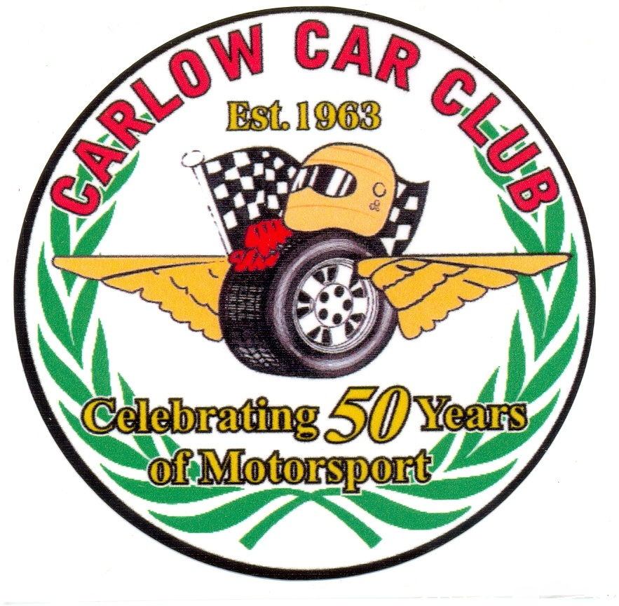

Carlow Hillclimb Weekend
1st JUNE & 2nd JUNE 2013
Rounds 5&6 of the
Hillclimb & Sprint Championship 2013

