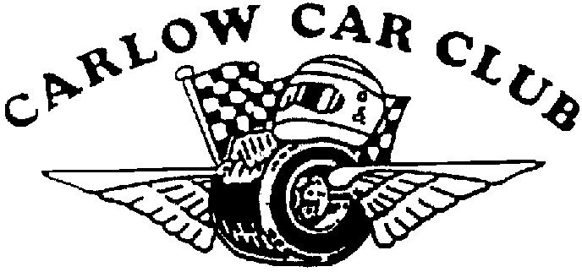
Carlow Hillclimb Weekend 1st and 2nd June 2013
Round 4&5 of the Naylor Engineering National Hillclimb & Sprint Championship 2013

FINAL INSTRUCTIONS Issued 30/05 (Event Permit No 13/084)

- Mechanical and Document Scrutiny will be held in the Paddock on both days from 8.00am – 10.00am.
Saturday 1st June in Johnswell, Kilkenny (will ne signposted from Junction 8 M9)
Sunday 2nd June in Bourt Malt (formerly Minch Norton) Bagenalstown, County Carlow.
Map available on Club website www.carlowcarclub.ie

2) Change of Officials MI Steward – Dave Fitzgerald
MI Safety Officer – Brendan Harpur
Chief Scrutineer – Jason Keogh
Bike Marshal – Sat – George Nolan
Bike Marshal – Sun – Michael Nolan
Paddock Marshal Sat 1st June– Martin Comerford
Paddock Marshal Sun 2nd June – Philip McDonald

- Drivers briefing both mornings at 10.10am sharp in the Paddock area

- Marshal Briefing both mornings 9.30am sharp in the Paddock Area (beside event office)

- Competitors please note the change to the Rallycar Classes as follows:

(8a) Rally cars up to 1450cc;
(8b) Rally cars 1451cc -1650cc - not more than two valves per cylinder;
(8c) Rally cars 1451cc - 1650cc – more than two valves per cylinder;
(9a) Rally cars 1651cc – 2050cc – not more than two valves per cylinder;
(9b) Rally cars 1651cc – 2050cc – more than two valves per cylinder

- All competing cars must use a large non porous mat when in the paddock area Penalty for not using this mat - 1 minute
- Competitors please respect the residents in service are and keep engine noise to a minimum before 10am – Penalty for excessive noise will be applied.

8) Further instructions may be posted

_______________________ 30/May/2013
Kenneth Treacy
Clerk of the Course

